ASSIGNMENT NO.6: Data Manipulation and Table Management

Student Name | Amit Panorekar | Roll Number | 20968
Batch | SY. BSc Data Science | Topic | WB(Assignment-6)

Q1) Create a MySQL database named CollegeDB and create two tables: Course and Student.
Course Table
Column Name | Data Type | Constraint
CourseID | INT | PRIMARY KEY
CourseName | VARCHAR(50) | NOT NULL
Fees | DECIMAL(10,2) | NOT NULL

Student Table
Column Name | Data Type | Constraint
StudentID | INT | PRIMARY KEY
StudentName | VARCHAR(50) | NOT NULL
Age | INT
City | VARCHAR(30)
CourseID | INT | FOREIGN KEY

QUERY:
CREATE DATABASE CollegeDB;

USE CollegeDB;

CREATE TABLE Course (
CourseID INT PRIMARY KEY,
CourseName VARCHAR(50) NOT NULL,
Duration VARCHAR(20),
Fees DECIMAL(10,2) NOT NULL,
Tier VARCHAR(20)
);

CREATE TABLE Student (
StudentID INT PRIMARY KEY,
StudentName VARCHAR(50) NOT NULL,
Email VARCHAR(100),
Phone VARCHAR(15),
Gender CHAR(1),
DateOfBirth DATE,
CourseID INT,
AdmissionDate DATE,
Age INT,
City VARCHAR(30),
FOREIGN KEY (CourseID) REFERENCES Course(CourseID)
);
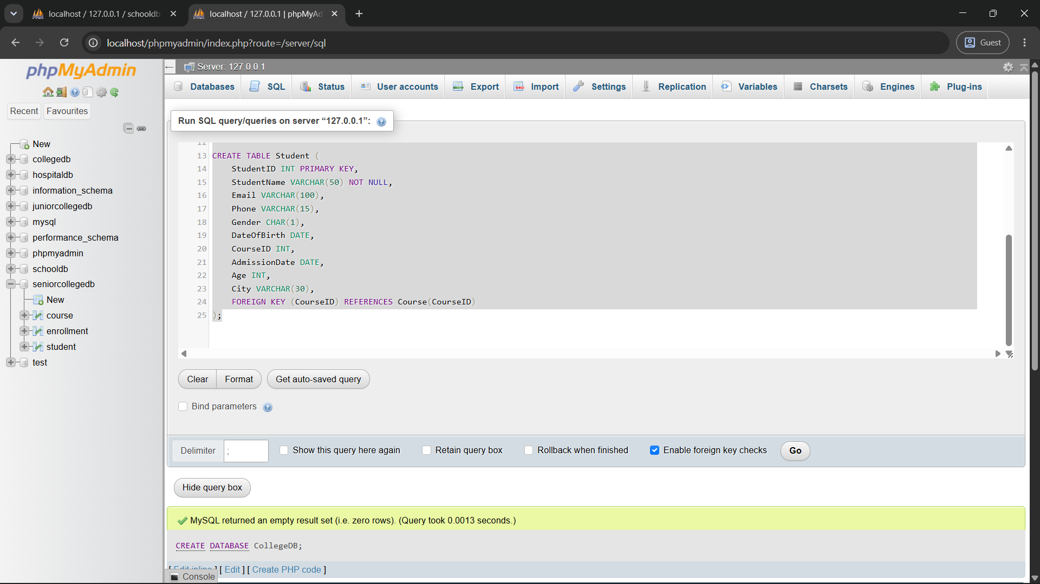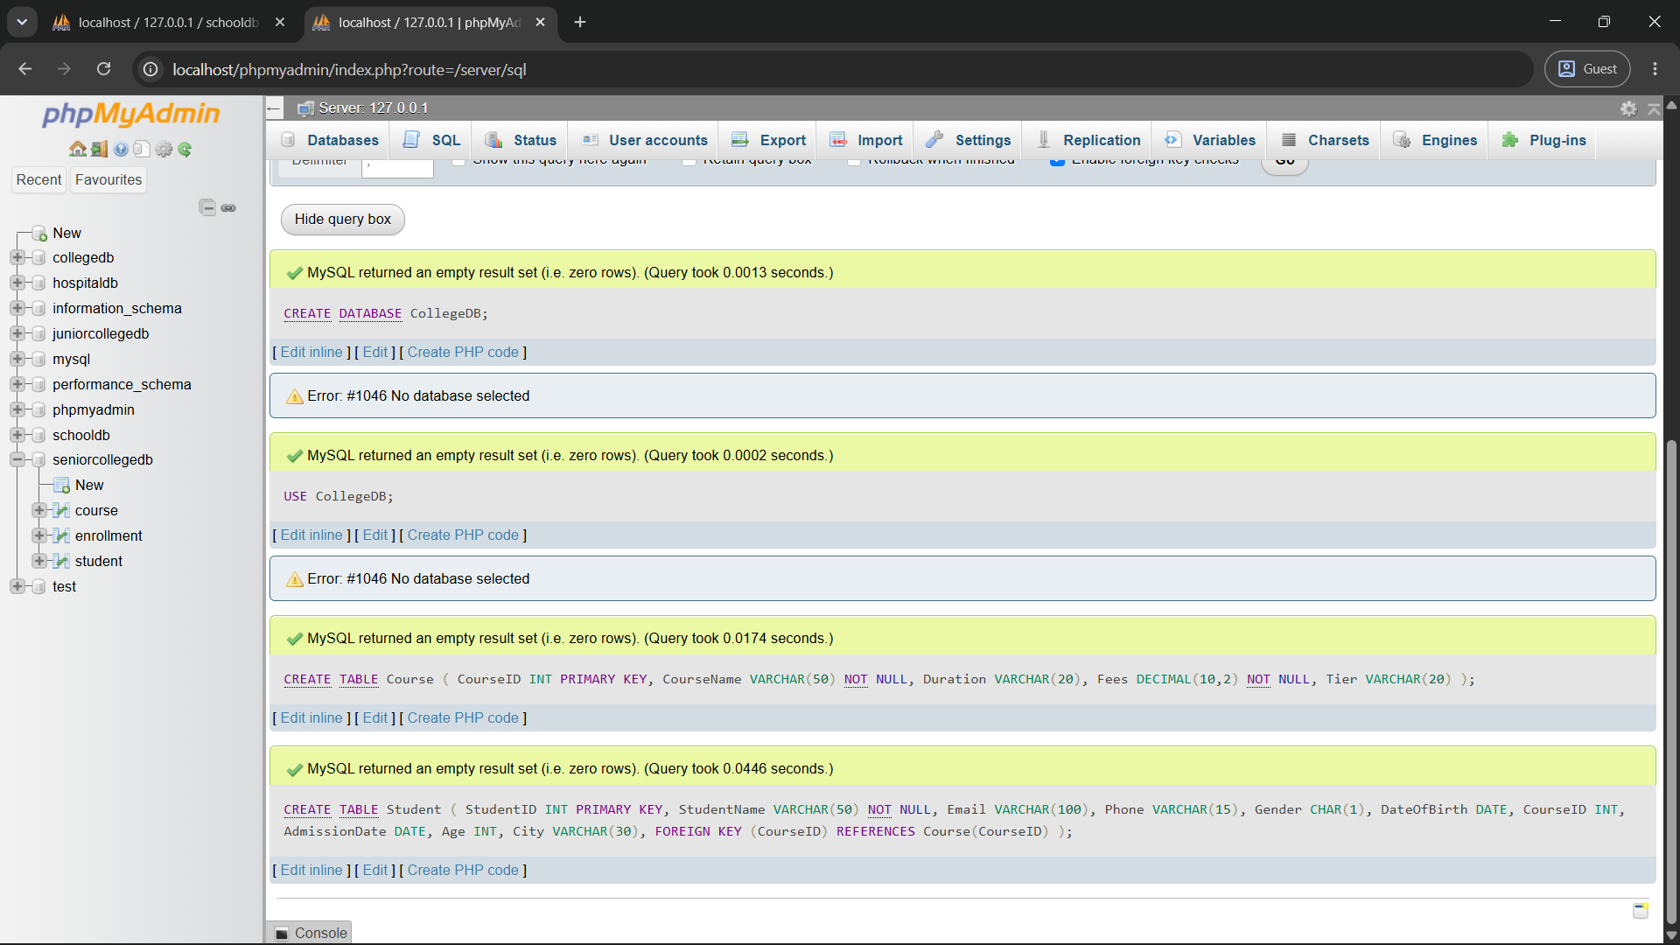

Q2) Insert at least 4 records into the Course table and 6 records into the Student table.

Make sure every student has a valid CourseID from the Course table.

QUERY:
INSERT VLAUES:
INSERT INTO course (CourseID, CourseName, Duration, Fees, Tier) VALUES
(101, 'B.Sc IT', '3 Years', 35000.00, NULL),
(102, 'BCA', '3 Years', 40000.00, NULL),
(103, 'BBA', '3 Years', 50000.00, NULL),
(104, 'Bsc DATA SCIENCE', '3 Years', 60000.00, NULL),
(105, 'MCA', '3 Years', 45000.00, NULL),
(106, 'B.Com', '3 Years', 60000.00, NULL),
(107, 'CSE', '4 Years', 80000.00, NULL),
(108, 'MSE', '2 Years', 50000.00, NULL);

INSERT INTO student (StudentID, StudentName, Email, Phone, Gender, DateOfBirth, CourseID, AdmissionDate, Age, City) VALUES
(1, 'Amit Sharma', 'amit@gmail.com', '9876543210', 'M', '2005-04-12', 101, '2026-07-07', 20, 'Mumbai'),
(2, 'Ram Mohan', 'ram@gmail.com', '9845563210', 'M', '2007-04-16', 102, '2025-06-17', 21, 'Delhi'),
(3, 'Anisa Patil', 'anisa@gmail.com', '9848809543', 'F', '2006-05-12', 103, '2024-04-03', 22, 'Pune'),
(4, 'Rita Nayak', 'rita@gmail.com', '9267563710', 'F', '2004-08-15', 104, '2025-03-23', 20, 'Mumbai'),
(5, 'Rohan Mehta', 'abc@gmail.com', '9875643993', 'M', '2004-11-25', 105, '2026-07-08', 23, 'Delhi'),
(6, 'Sneha Joshi', 'sneha@gmail.com', '9854326710', 'F', '2009-08-23', 106, '2026-07-08', 21, 'Nashik'),
(7, 'Arjun Nair', 'arjun@gmail.com', '9876540321', 'M', '2009-08-24', 107, '2026-08-05', 24, 'Pune'),
(8, 'Aditya Ballal', 'aditya@gmail.com', '9876004532', 'M', '2009-08-25', 108, '2026-05-18', 21, 'Mumbai'),
(9, 'Vikas Sharma', 'vikas@gmail.com', '9876541111', 'M', '2005-01-10', 102, '2026-07-26', 20, 'Thane');

OUTPUT:

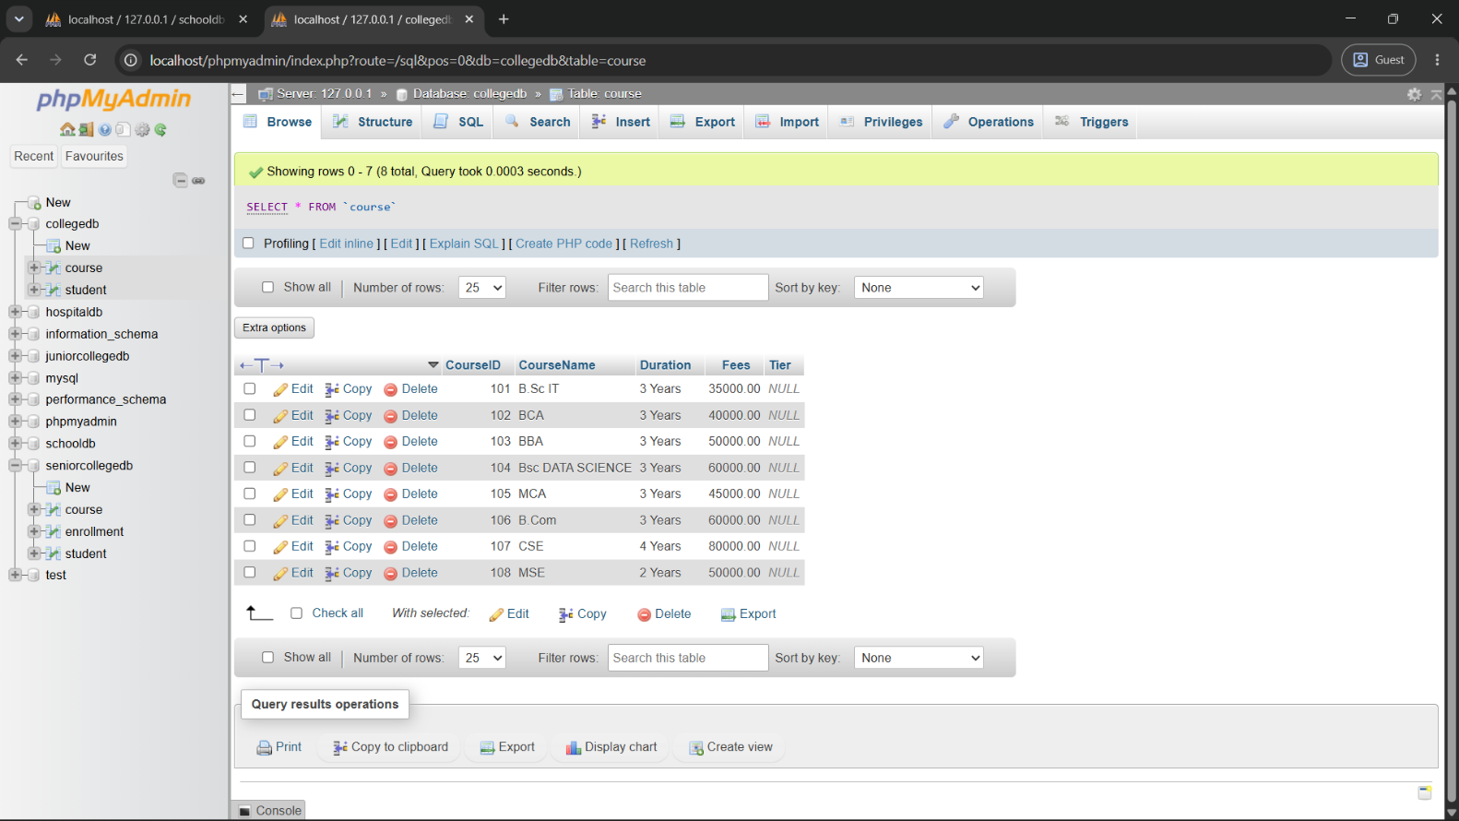

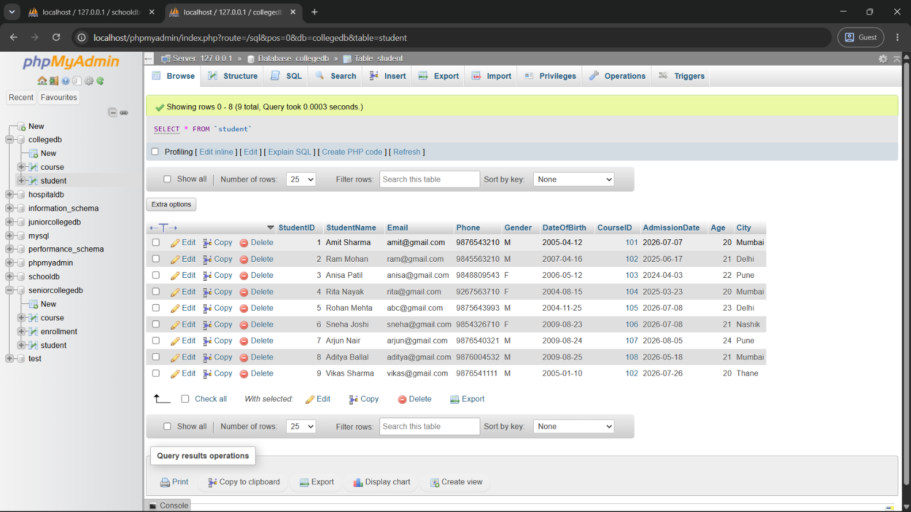

Q3) Write a MySQL query to insert one new student record into the Student table.
The record sould include:
Field
StudentID
StudentName
Age
City
CourseID

QUERY:

--Q3) Insert one new student record

INSERT INTO Student

(StudentID, StudentName, Age, City, CourseID)

VALUES

(10, 'Rohit Desai', 21, 'Mumbai', 103);

-- Verify: SELECT * FROM Student

WHERE StudentID =10;

OUTPUT:

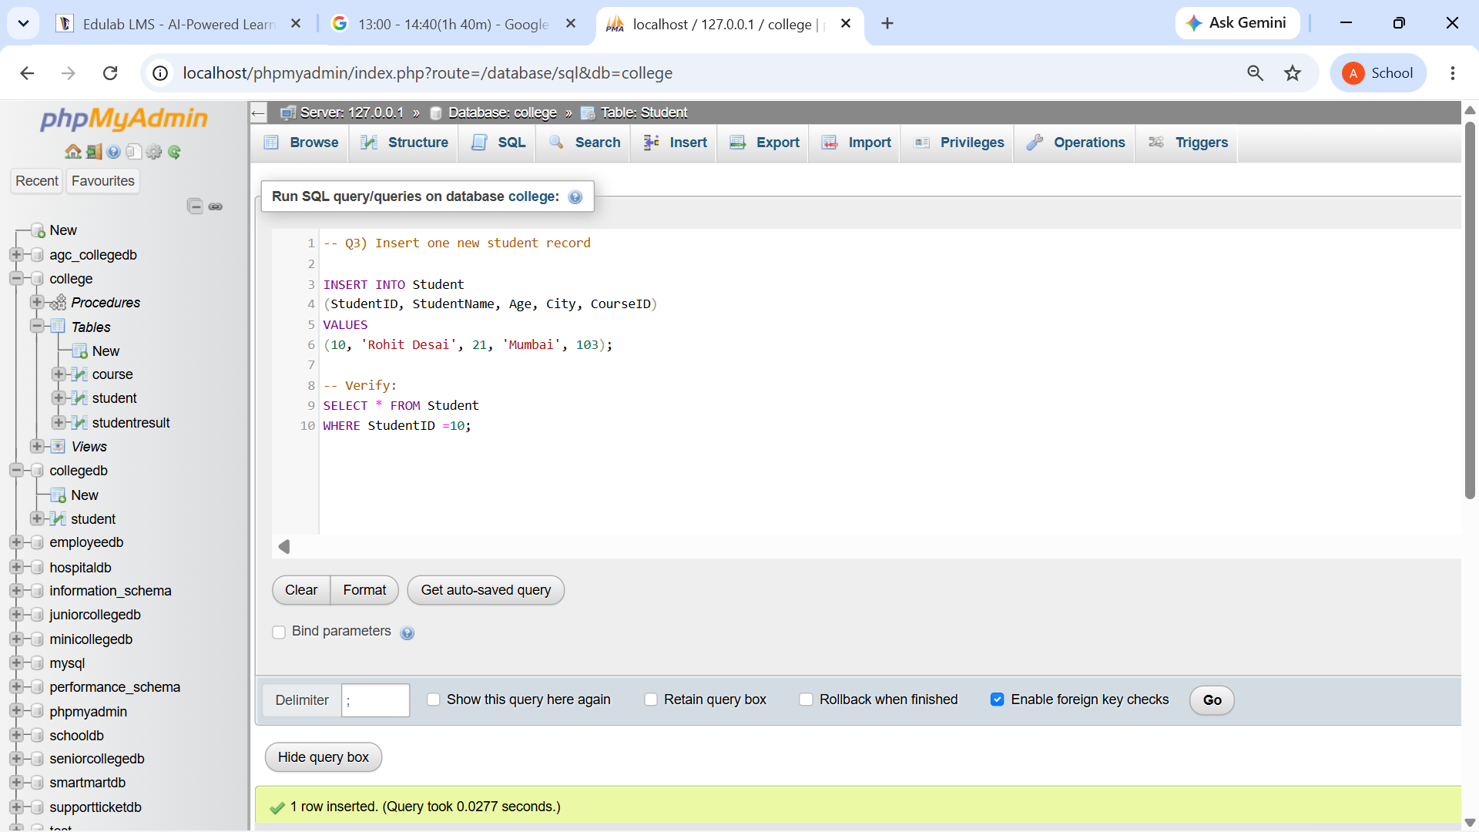

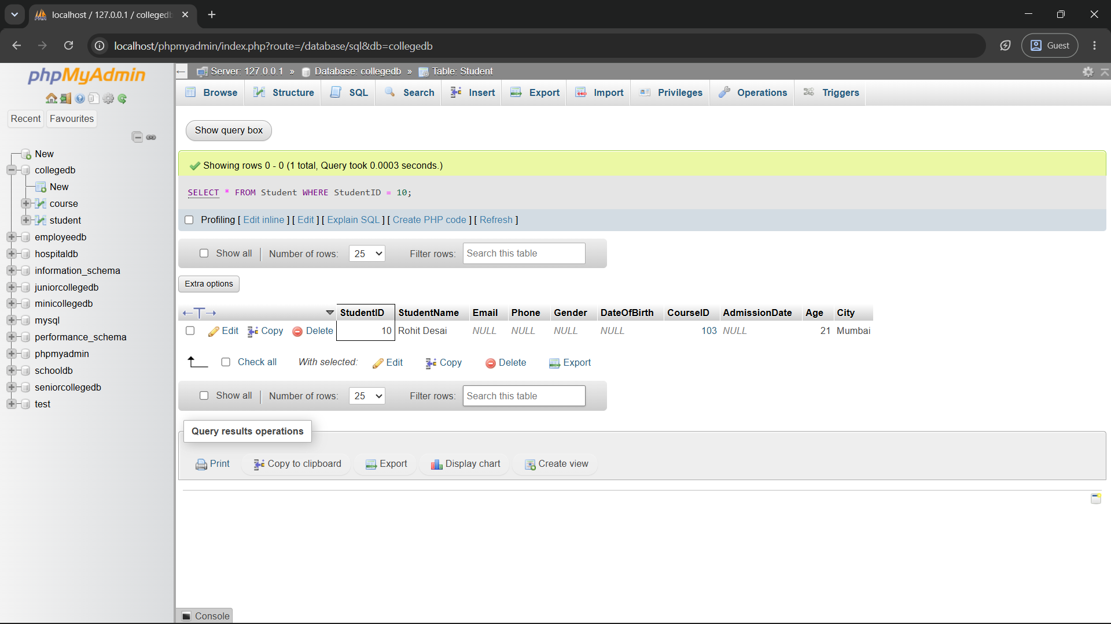

Q4) Write a MySQL query to update the city of a student using StudentID.
Example requirement:
Change Required
Update the city of StudentID 2 to Mumbai

QUERY:

-- Q4) Update the city of StudentID 2 to Mumbai

UPDATE Student

SET City = 'Mumbai'

WHERE StudentID = 2;

-- Verify:

SELECT * FROM Student

WHERE StudentID = 2;

OUTPUT:

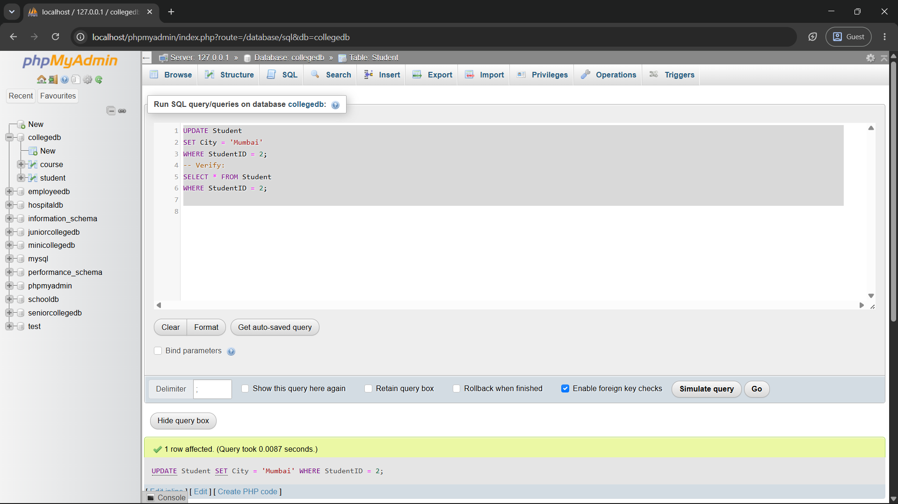

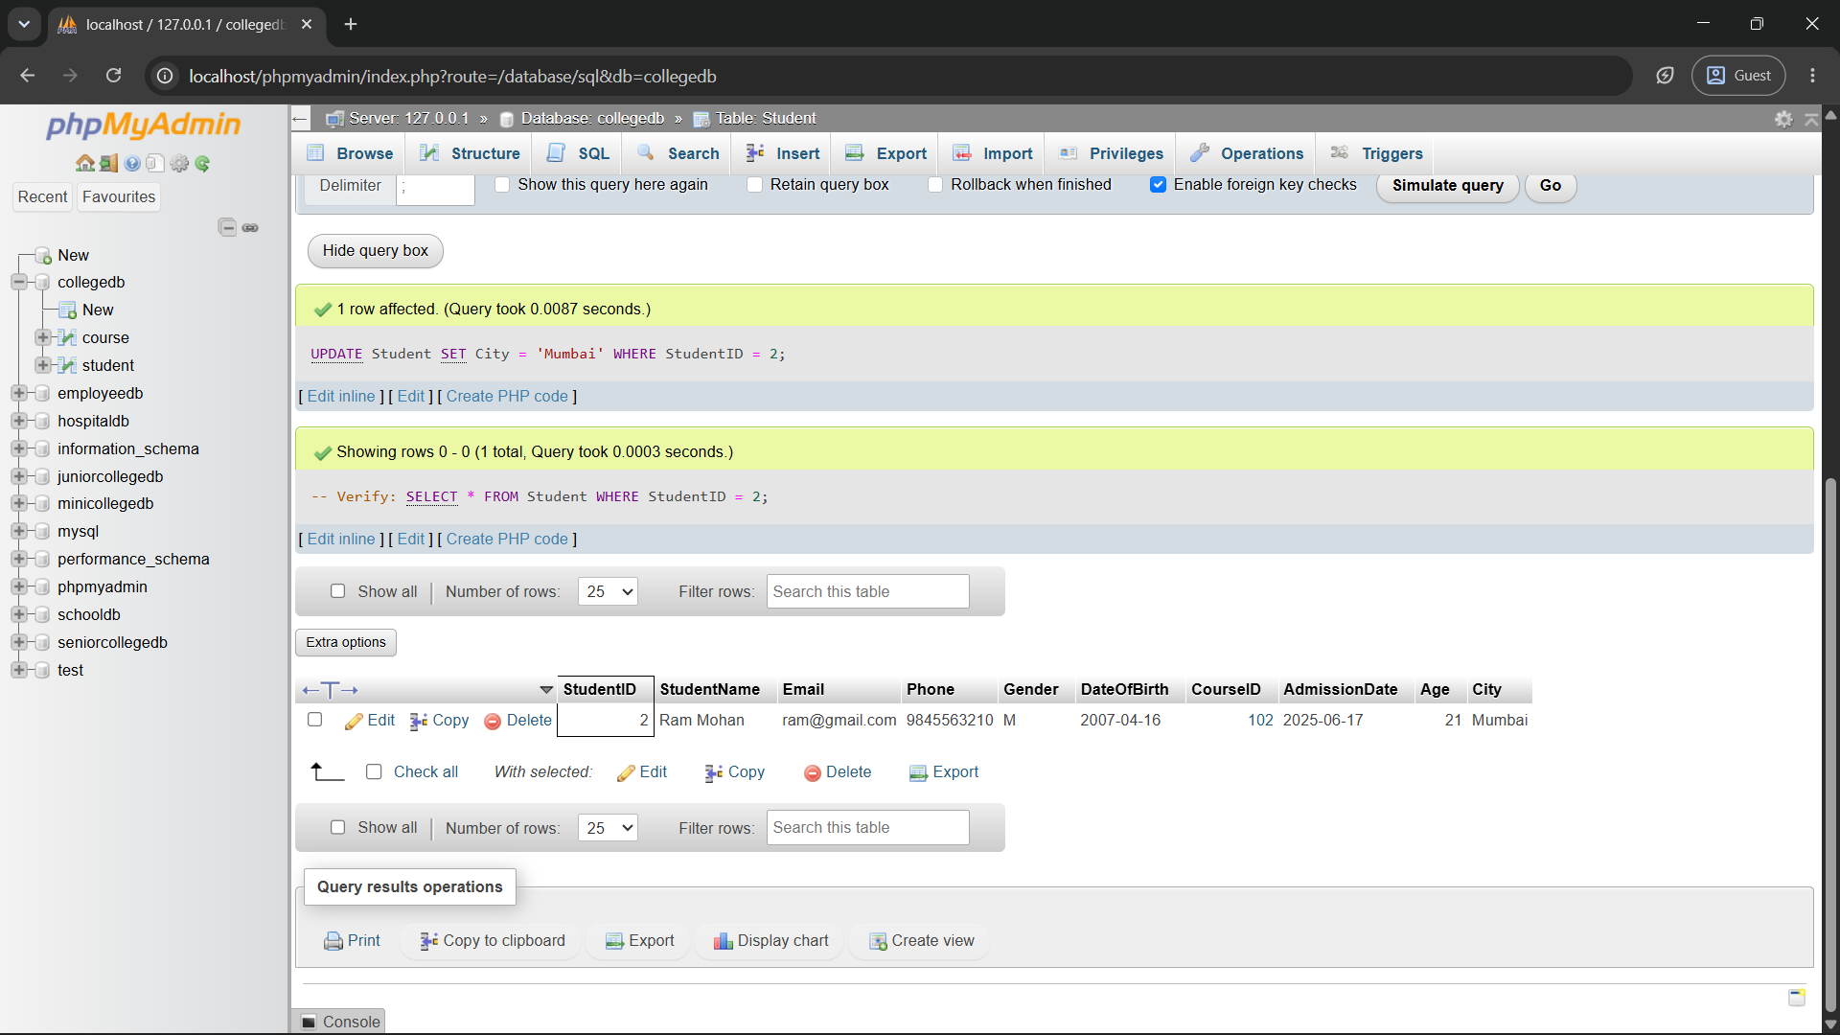

Q5) Write a MySQL query to update the fees of a course using CourseID.
Example requirement:
Change Required
Update the fees of CourseID 101 to 47000

QUERY:

Q5) Update fees of CourseID 101 to 47000

UPDATE Course

SET Fees = 47000.00

WHERE CourseID = 101;

Verify:

SELECT * FROM Course WHERE CourseID = 101;

OUTPUT:

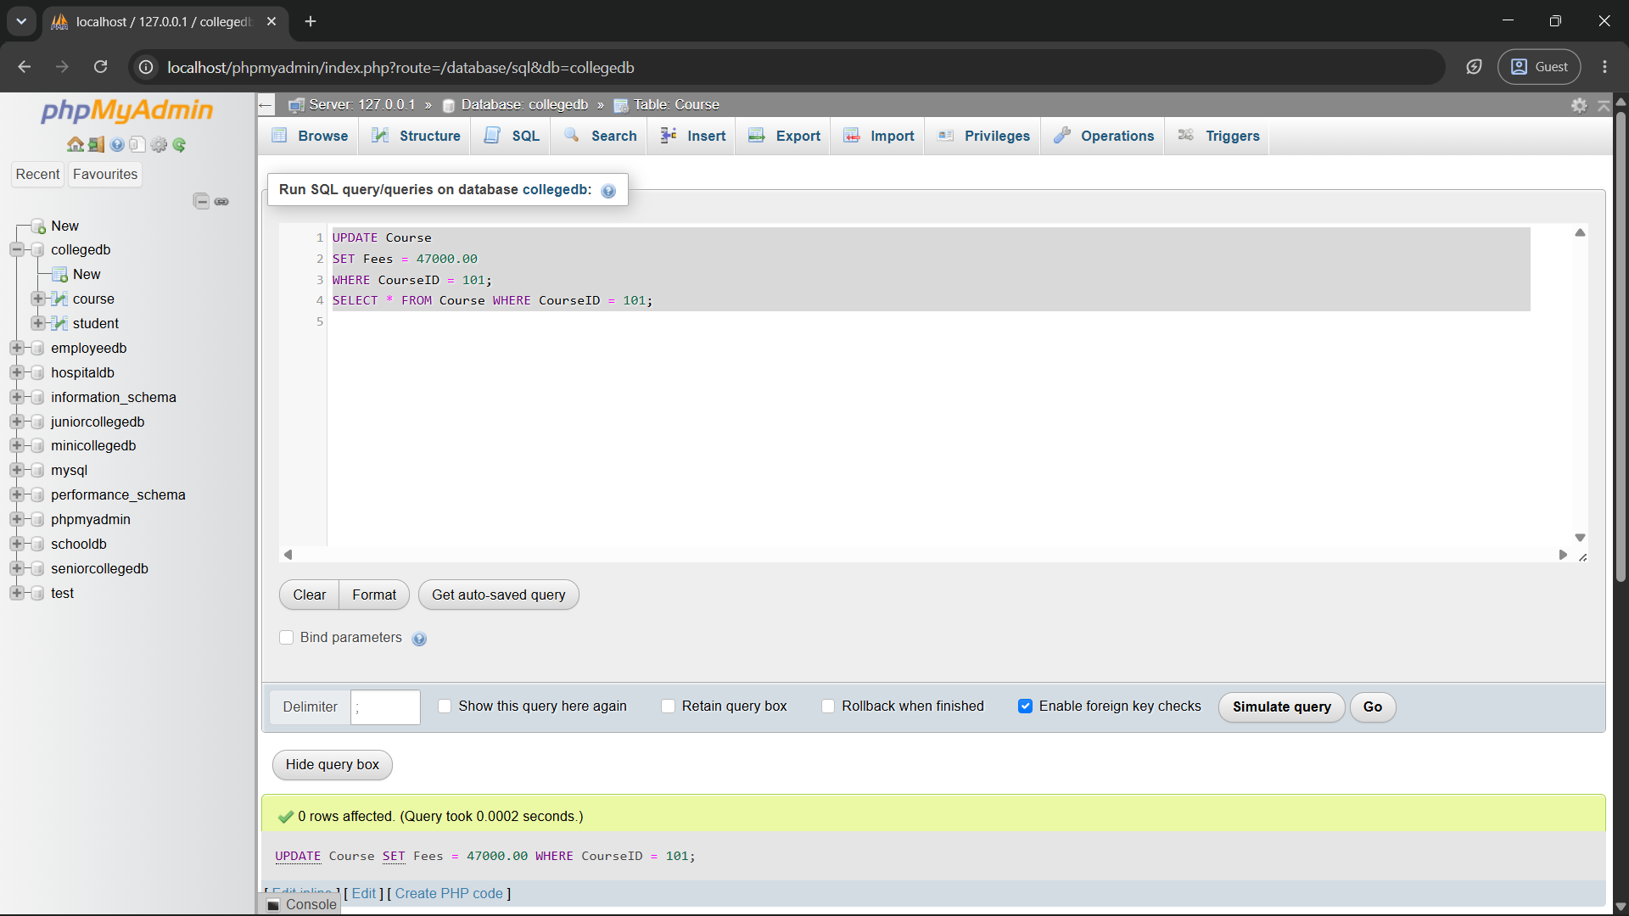

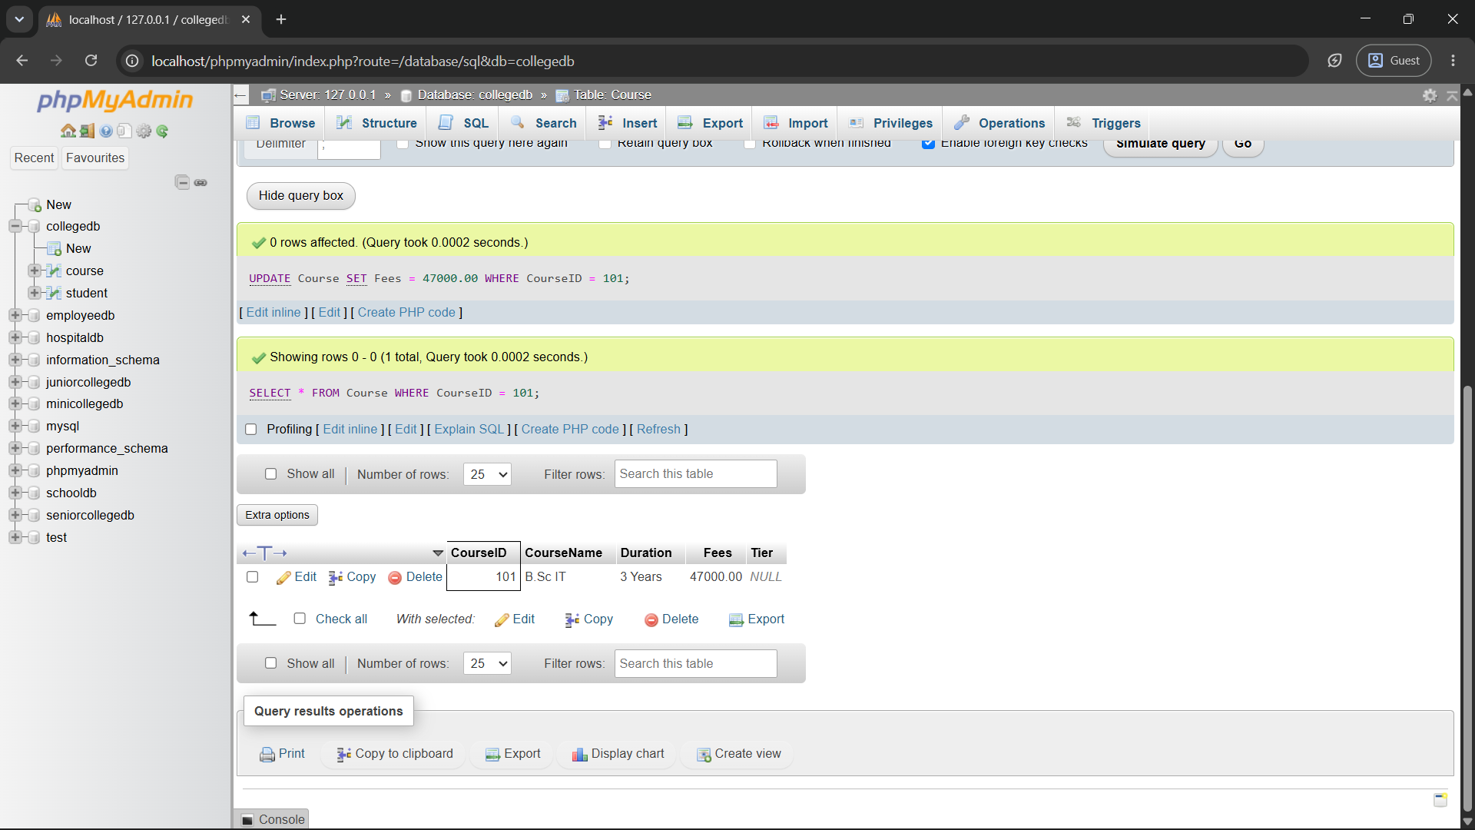

Q6) Write a MySQL query to delete one student record using StudentID.
Also write one line explaining why the WHERE clause is important while using DELETE.

DELETE FROM Student
WHERE StudentID = 6;

Verify:
SELECT * FROM Student;

The WHERE clause ensures that only the specified student record is deleted.
Without WHERE, all records from the Student table would be deleted.
